
The Dunkirk
New Pupil Buddy Guide
A (New Pupil Buddy) will:
Show patients – give our new buddy time to be quiet.
Be kind – be there to help, when needed.
Guide – guide our new friends around school, showing them where to go and what to do.
Be a good role model – model the behaviour of our Dunkirk P.R.I.D.E values.
Translate – if you share the same language help to translate, when needed.
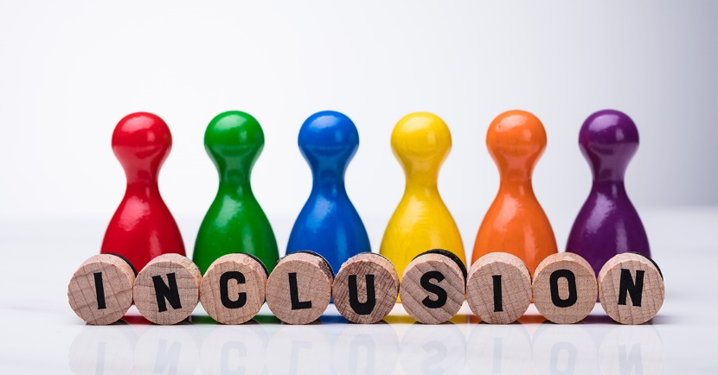
Be a friend – most important of all. Show our new friend all of the above and you will become a valued friend to them.

